FINANCIAL MANAGEMENT

By Student’s Name

Code + Course Name

Professor’s Name

University Name

City, State

Date

Financial Management

The phrase financial management refers to the efficient as well as efficient management of the available funds, in order to accomplish an organization’s goals or objectives efficiently. In most organization, financial management is a specialized function that is directly undertaken by the top management level in an organization. One of the primary roles of financial management in an organization is the management of both the receivables or debtors and inventories or stock. This essay will focus on the importance of managing receivables or inventories in an organization through an analysis of the financial statements of the Advanced Medical Solutions Group (AMS) as well as GlaxoSmithKline PLC (GSK).

Debtors (Receivables) and Stock (Inventories)

In a business organization, debtors are those persons or entities that owe money to the business. Consequently, when the business attains funds, such debtors, it is said to have attained receivables. On the other hand, the term inventories characterize an entity’s raw materials, completed goods as well as work in progress products, which are all parts of a business’ assets and meant for sale. The primary advantage of debtors is that they offer business to an entity by making purchases.

However, a lot of debt reduces the working capital of business, and this can affect its normal operations. On the other hand, the stock is part of an entity’s asset, and through its sale, a business can earn profits. Nevertheless, stagnated stock can cause a loss to the business through spoiling, in the case of perishable products, or through accrued costs such as storage costs. Nevertheless, there is a close relationship between debtors and stock in that the business must have the two components in order to function effectively.

Significance of Managing Receivables and Inventories in the Organization

Financial management has numerous advantages to the concerned corporations. This is because it facilitates a smooth flow of an institution’s operations by ensuring that there is sufficient operating capital. It also aids the management team in an organization to base all its financial decisions based on the current financial records of the organization. This way, all decisions made are offered sufficient capital resources, which consequently promotes the attainment of the organization’s financial objectives. Ultimately, financial management of receivables and stock enables the management department to measure the performance of the organization.

Brief Introduction About AMS and GSK Corporations

This analysis will focus on the financial statements of AMS and GSK Corporations. The choice of these companies is based on the reason that their financial periods close at the same period, which is on December 31, annually. The companies are also listed on the London Stock Exchange (LSE) market, where they retail their shares publicly. Also, the corporations operate within the same industry of health care services provision to the public.

AMS, on the other hand, offers develops advanced products for wound care services and surgical equipment meant for wound dressing (AMS, 2017). It is globally renowned for its emphasis on the value for its clients as well as attainment of quality patient outcomes through its services. GSK produces pharmaceutical products for treating various medical conditions (GSK, 2017). It among the largest pharmaceutical companies in the United Kingdom.

Companies Analysis and Comparisons

The company analysis will compare the proportion of receivables (debtors) as well as inventories (stocks) for each company during the last financial period that ended on December 31, 2016. Nevertheless, a comparison of the companies’ receivables and inventories will also be performed for the year 2012 up to 2015. A detailed calculation of stock and debtors’ ratios for the corporations will also be included together with appropriate financial performance graphs or charts for each corporation over the last five years.

Debtors Ratio

*Formula for Debtors Ratio*

Debtors Ratio = (Trade Receivables / Revenues (Sales) x 365

GSK Corporation

|  |  |  |  |
| --- | --- | --- | --- |
| End of Financial Year as at December 31. | Trade Receivables - Currency in GBP Billions | Revenues/Sales – Currency in GBP Billions | Debtors Ratio (Days) |
| 2016 | 8.47 | 27.89 | 110.84 |
| 2015 | 8.86 | 23.92 | 135.20 |
| 2014 | 7.81 | 23.01 | 123.89 |
| 2013 | 8.72 | 26.51 | 120.06 |
| 2012 | 8.31 | 26.43 | 114.76 |

AMS Corporation

|  |  |  |  |
| --- | --- | --- | --- |
| End of Financial Year as at December 31. | Trade Receivables | Revenues/Sales - Currency in Euro in Millions | Debtors Ratio (Days) |
| 2016 | - | 563 |  |
| 2015 | 89 | 623 | 52.14 |
| 2014 | 79 | 464 | 62.14 |
| 2013 | 64 | 378 | 61.79 |
| 2012 | 42 | 388 | 39.51 |

Debtors ratio is a measure of how a business collects cash from all its debtors, and it is expressed in days (Bagad, 2008). The longer the time taken by the company to collect its debts, the greater the debtors’ ratio or the number of debtors’ days. In reference to the two featured corporations, AMS Corporation’s debtors’ ratio is greater than that of GSK Corporation. This means that AMS has a better debtors’ management policy and as such it has more working capital in reference to its total invested capital. The difference in the two corporations’ debtors days could be as a result of factors such as industry practice, billing errors, investment in collection staff and credit practices of each corporation (Bragg, 2013).

Stock Ratio

*Formula for Stock Ratio*

Stock Ratio = Cost of Goods Sold / Average Stock

GSK Corporation

|  |  |  |  |
| --- | --- | --- | --- |
| End of Financial Year as at December 31. | Cost of Goods Sold - Currency in GBP Billions | Average Stock - Currency in GBP Billions | Stock Ratio |
| 2016 | 7.08 | 6.91 | 1.024 |
| 2015 | 7.29 | 7.21 | 1.011 |
| 2014 | 5.96 | 6.97 | 0.855 |
| 2013 | 6.78 | 6.1 | 1.039 |
| 2012 | 6.34 | 6.29 | 1.008 |

AMS Corporation

|  |  |  |  |
| --- | --- | --- | --- |
| End of Financial Year as at December 31. | Cost of Goods Sold - Currency in GBP Billions | Average Stock - Currency in Euro in Millions | Stock Ratio |
| 2016 | 261 | - | - |
| 2015 | 284 | 80 | 3.55 |
| 2014 | 211 | 60 | 3.52 |
| 2013 | 180 | 40 | 4.50 |
| 2012 | 185 | 56 | 3.30 |

Stock ratio is employed to illustrate how effectively an entity’s stock is managed over an accounting period. It is formulated through the calculation of the cost of all the goods sold in an organization divided by the average value or amount of inventories in an organization (Bose, 2006). In reference to the two organizations, it is evident that the AMS Corporation has a higher stock ratio in comparison to the GSK Corporation. Both the stock and debtors ration of the AMS Corporation is better that those recorded for the GSK Corporation. This result can be employed to justify that the AMS Corporation is performing at a better rate that the GSK Corporation within the same financial period.

The knowledge of the stock ratio is also important in an organization as it is a primary indicator of the profitability potential of a business organization. A high stock ratio indicates that an entity is retaining a low level of its average stock in comparison to its sales. In this case, holding stock refers to the funds tied up in the company’s stock. Also, retaining a high level of inventories on business premises is not recommended because it attracts additional costs. Such costs may include costs that relate to storage, spoilage, theft or changes in the customers’ style, tastes, and preferences.

Conclusion

In conclusion, managing receivables or inventories in an organization are important because it is a primary indicator of the sustained performance of an institution. There are two primary financial ratios that can be used in the analysis of a business’ receivables and inventories. The debtors’ ratio is a measure of how an entity collects cash from all its debtors, and it is expressed in days. The longer the time taken by the corporation to collect its debts, the greater the debtors’ ratio or the number of debtors’ days. On the other hand, the stock ratio is used to illustrate how effectively an entity’s stock is managed over an accounting period. It is formulated through the calculation of the cost of all the goods sold in an organization divided by the average value or amount of inventories in an organization.

Recommendations

From the financial analysis, it is evident that the two corporations’ financial positions in an ideal status. Nevertheless, further improvement of their financial management methodologies is warranted to ensure that entities continue having an improved performance. This is also because both the accounts receivables as well as inventory accounts are all primary components of the working capitals of any business entity. Also, by streamlining the two components, the corporations will be in a position to have good access to the cash that would otherwise be trapped on the balance sheets. There are several strategies that the corporations could use as recommendations for improving the financial managements, in reference to their receivables and inventories.

Optimizing the Financial Functions

This is the first financial management strategy that both companies should adopt. There are numerous optimization techniques that the companies could employ for improving the companies’ cash management. For example, the accounts receivables for both corporations could be optimized by minimizing the error rates on the invoices. The financial managers in the two corporations could also adopt a regular schedule for following up on the collections. Also, from the inventories perspectives, the financial managers could periodically analyze the inventories accounts with an objective of identifying the slow-moving, non-profitable and obsolete stock.

Adoption of Advanced Technologies for Shortening the Cash Conversion Cycles

Due to the efficiency of modern accounting programs, enhanced cash conversion cycles in the organizations could be attained. The two corporations should keep an updated electronic system meant for optimizing various financial management functions. Such functions might include electronic delivery of invoices instead using mail or courier services. This will aid in speeding up billing of debtors and access to the debtors. This strategy will aid the companies in having a timely reporting of receivables and stock and as a result acquiring proactive measures meant for resolving delinquent accounts.

References List:

AMS, 2017. *Advanced Medical Solutions.* [Online]   
Available at: http://www.admedsol.com/

Bose, C. D., 2006. *Inventory Management.* New Delhi: PHI Learning Pvt. Ltd..

Bragg, S., 2013. *What is Debtors Day Calculation?.* [Online]   
Available at: http://www.accountingtools.com/questions-and-answers/what-is-the-debtor-days-calculation.html

GSK, 2017. *Annual Report and Responsible Business Supplement 2016.* [Online]   
Available at: http://www.gsk.com/

Bagad, V.S. 2008. *Managerial Economics And Financial Analysis.* New York: Technical Publications.

Appendices

AMS AG Income Statement

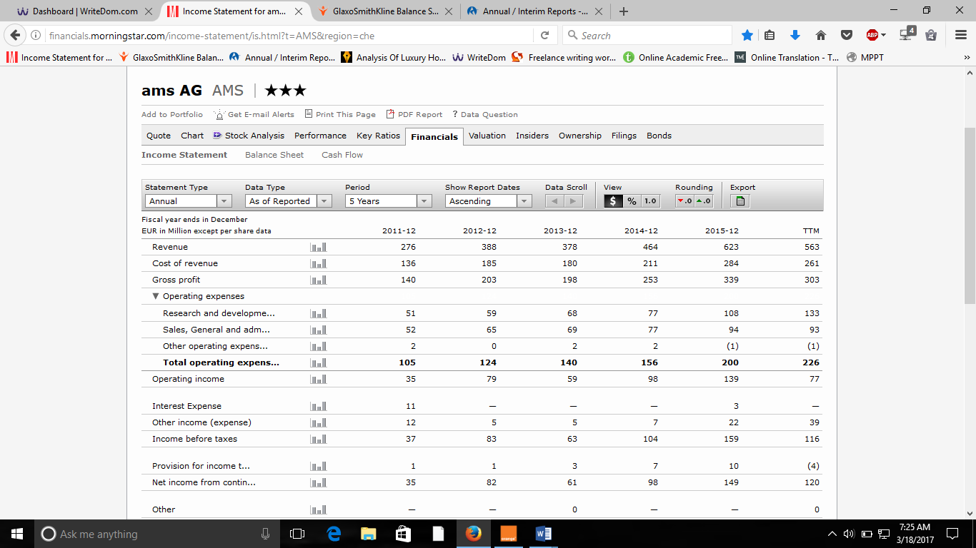

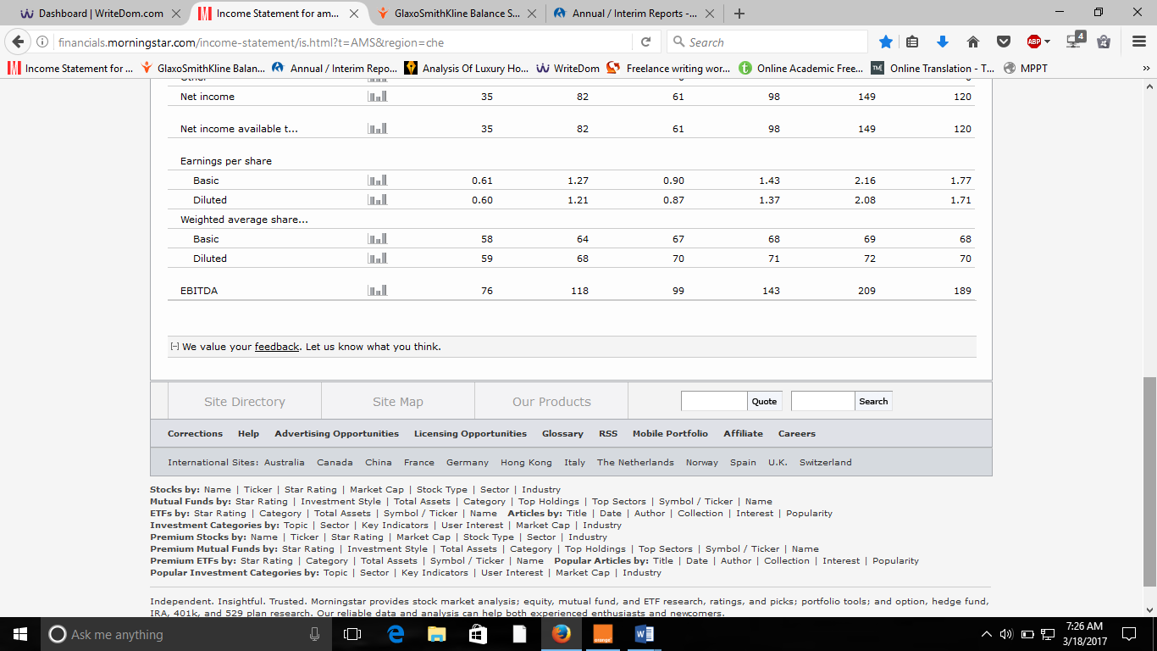

AMS AG Balance Sheet

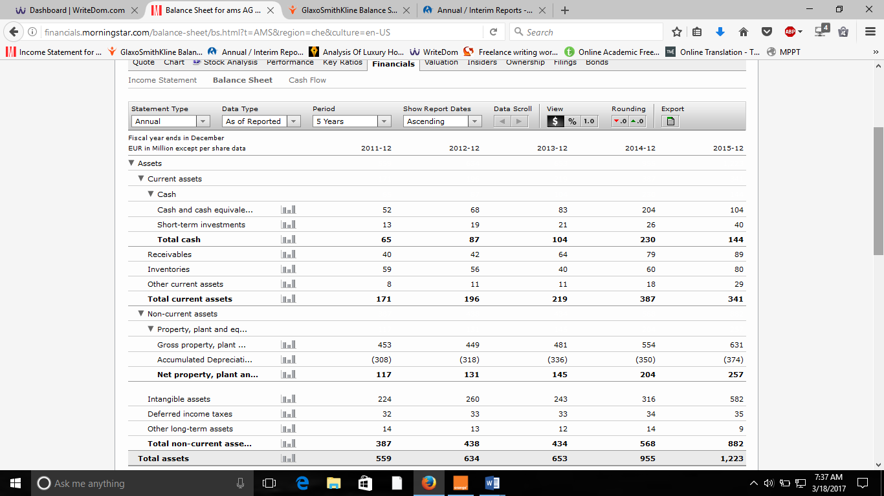

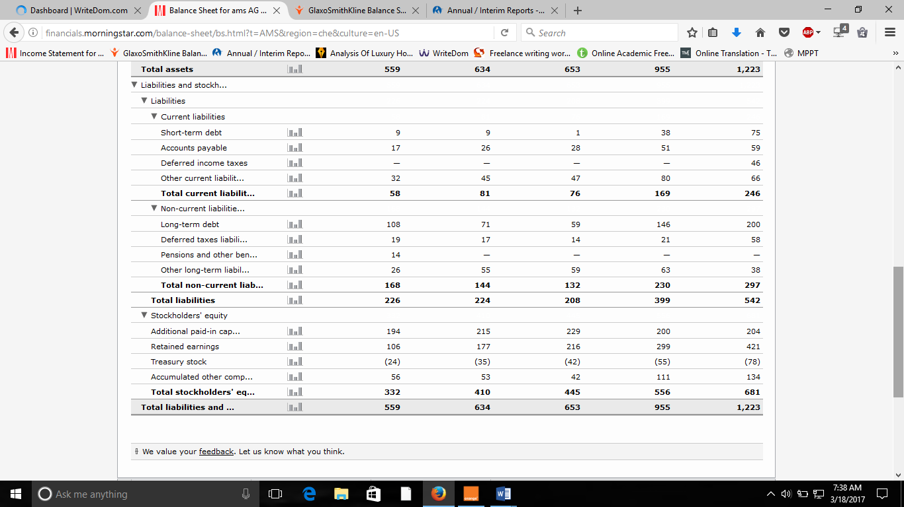

GSK Income Statement

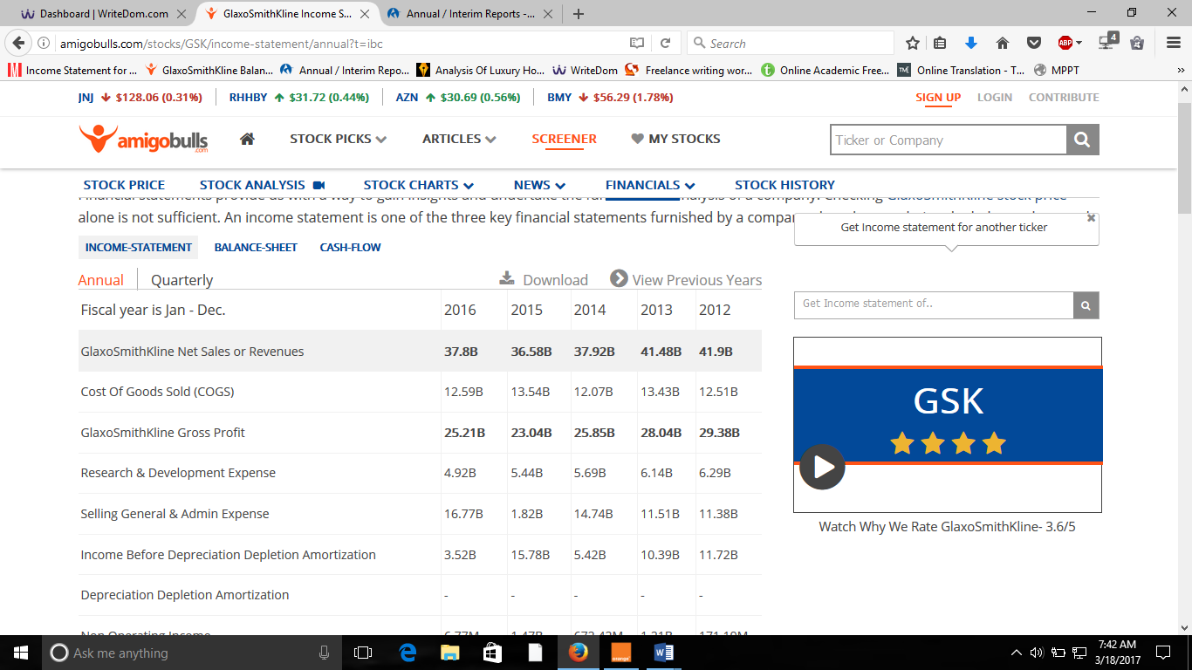

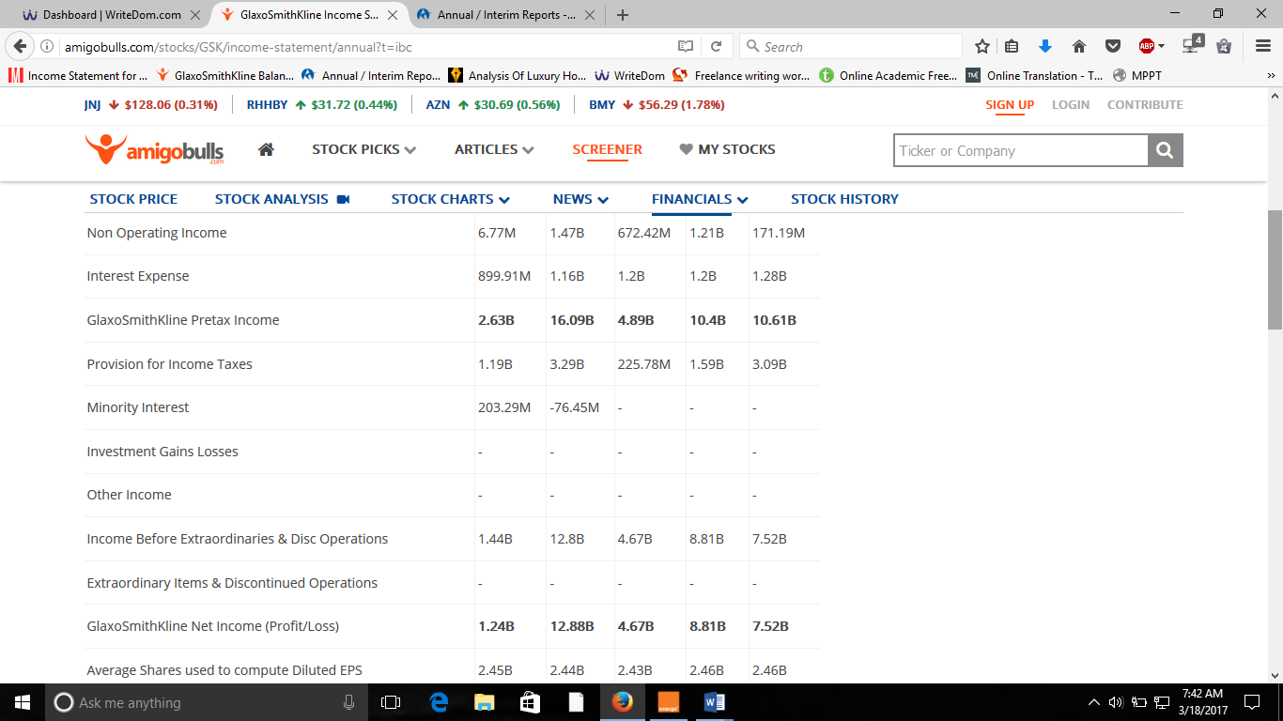

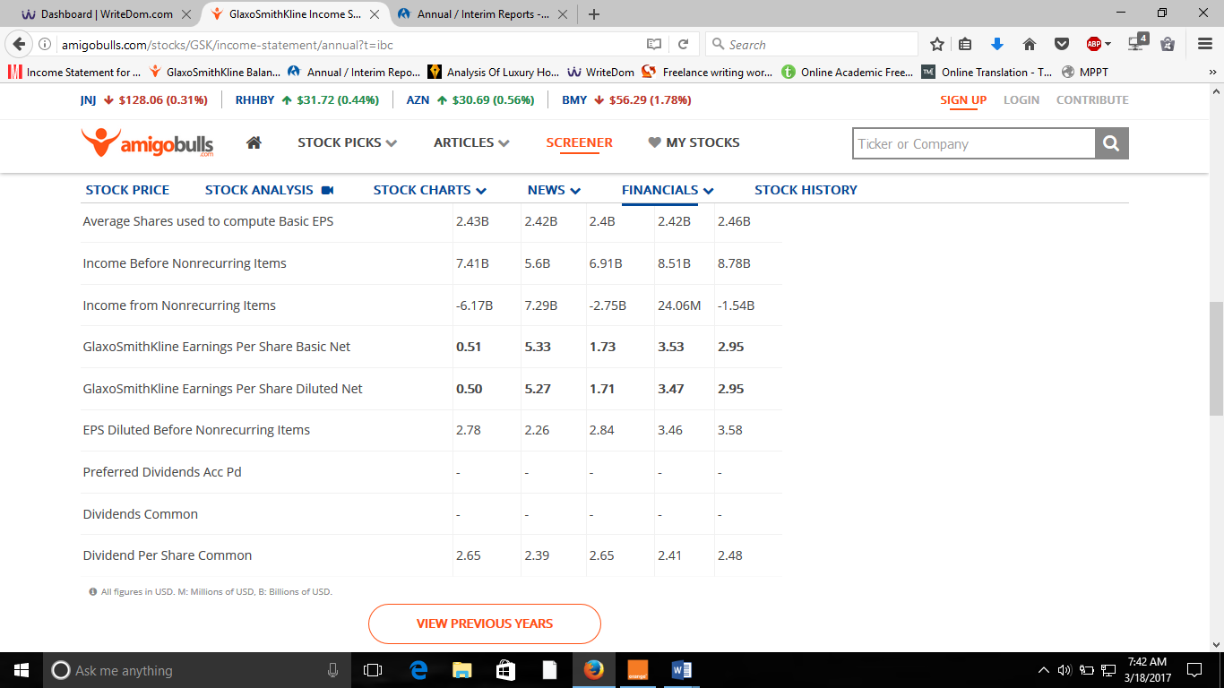

GSK Balance Sheet

